Meath based glass artist Deirdre Rogers will be running the following courses from her studio near Kentstown /Garlow Cross, Navan
For bookings contact Deirdre on 086 8117969 or email deirdre@deirdrerogers.com

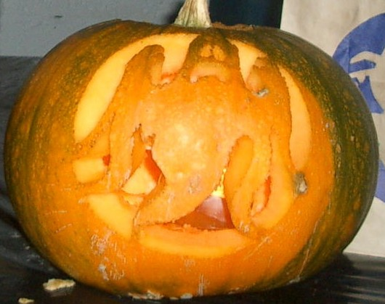
Wed. 29th Oct 2008 evening course 8pm to 10pm
Pumpkin Carving & Festive Crafts €30

Enjoy a fun evening designing and carving a pumpkin for your doorstep. We will also be making paper lanterns to decorate
your garden and simple projects to do with children at
Halloween.

Pumpkin, carving tools, festive recipes and light refreshments will be provided on the evening.
This course can also be adapted for the children in the classroom.
-----------------------------------------------------------------------------------------------------
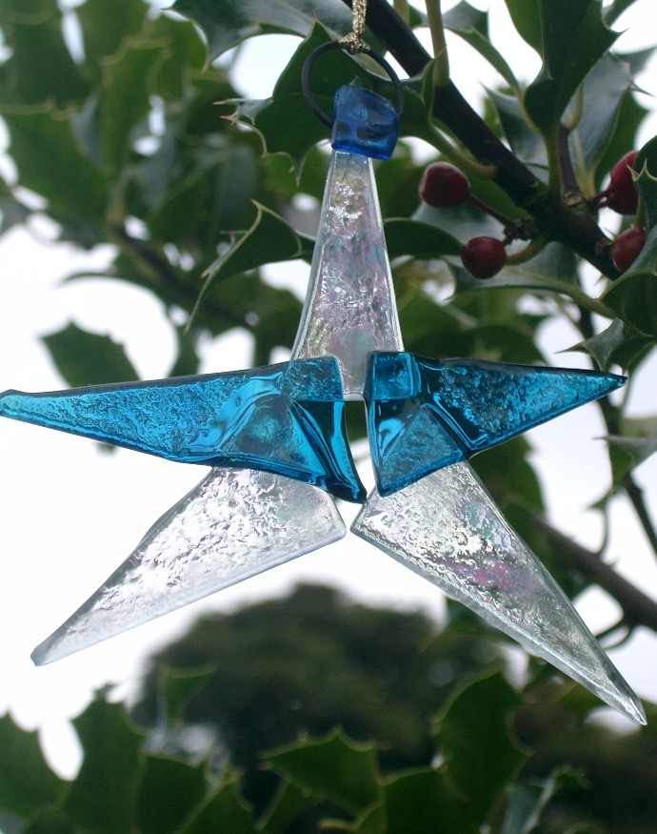
Sat. 29th & Sun. 30th Nov. 2008
2-day course (10am-4.30pm each day) €150
‘Make your own glass Christmas decorations & small gifts’ Participants will learn how to cut and shape colourful glass forms. These will be fused together in a kiln and finished with engraved or sandblasted detail. These can be hung from your tree, used as personalised swing tags or given as gifts.
No glass making experience necessary just a little imagination and lots of fun.
All materials and light lunch will be provided.

SPRING COURSES 2009

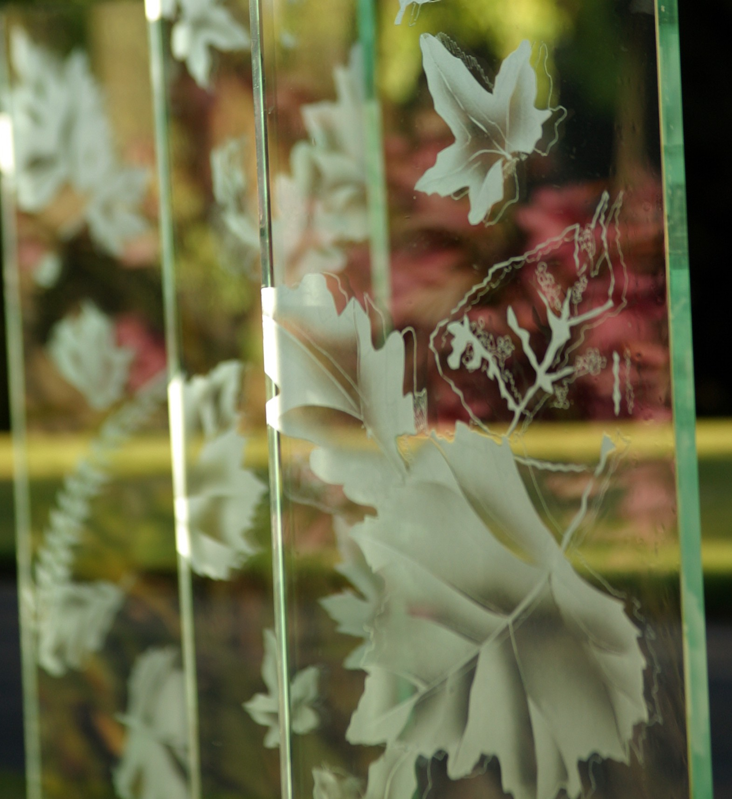
Sat.21st - Sun. 22nd and Sat. 28th Feb 2009
3-day course (10am-4.30pm each day)
‘Sandblasting as an art form’ €200
(Basic design & glass skills necessary)
Participants will be using images or drawings with Adobe Photoshop. Using UV light these images will be converted into ‘resists’, applied to glass sheet and sandblasted.

Experimentation with the etched surface, layering and manipulation of imagery with enamel will be the main focus of this workshop.

All materials and light lunch will be provided.
-----------------------------------------------------------------------------------------------------
Sat.11th - Sun. 12th April 2009 2-day course (10am-4.30pm each day) €80

‘Create your own work of art!’
- Mono printing from glass plates
Using leaves, found objects and paper cuttings we will be composing a picture on glass plates. These fun images can be printed over again to create interesting and unique paintings to be hung in your house, given as gifts or used in card making.
Mate All materials and light lunch will be provided.

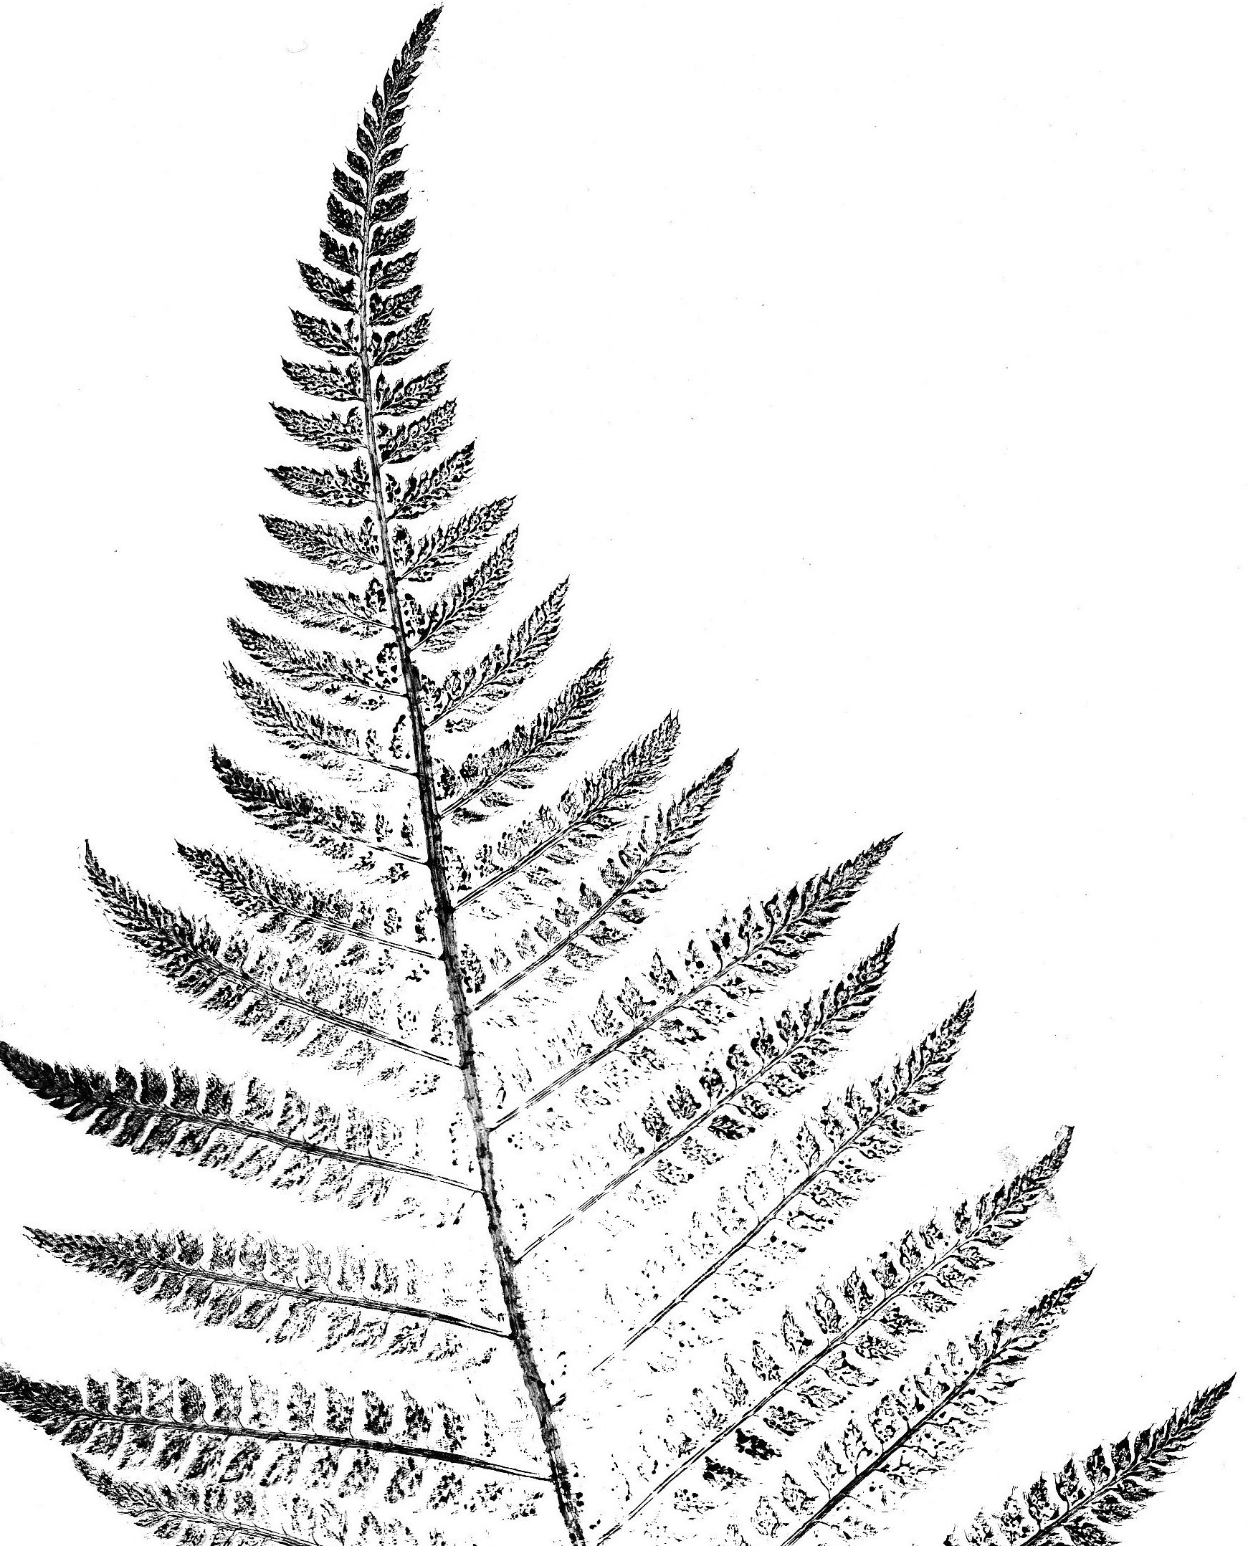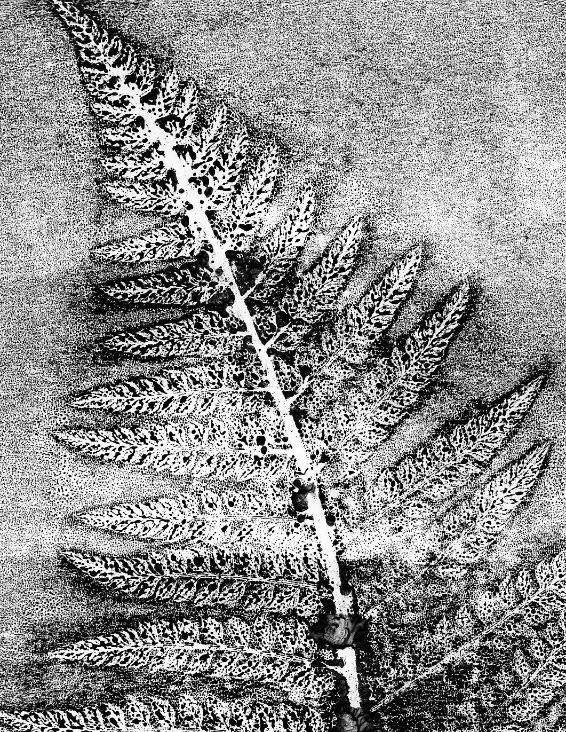
This course can also be adapted for the children in the classroom.

